Læs kapitel 2 66-147
Når det bliver for svært gå videre til næste delkapitel
Prioriter forståelse af kredsløb med få forgreninger, altså 1, 2 eller 3 delkredsløb, og vend tilbage til de sværere senere hvis de driller.
Især 2.5 Handler om teknikker til analyse af komplicerede kredsløb med mange forgreninger. Dem kigger vi ikke så dybt i nu, men vender evt. tilbage til dem senere.

Chapter 2: Resistive Circuits
1. Resistors, Series and Parallel Resistive Circuits
Resistors are passive components that oppose the flow of current, and this opposition is characterized by their resistance value.
- Series Circuits: When resistors are connected end-to-end, they share the same current. The total resistance $R_{total}$​ of resistors in series is the sum of individual resistances: $R_{total}=R_{1}+R_{2}+R_{3}+…$
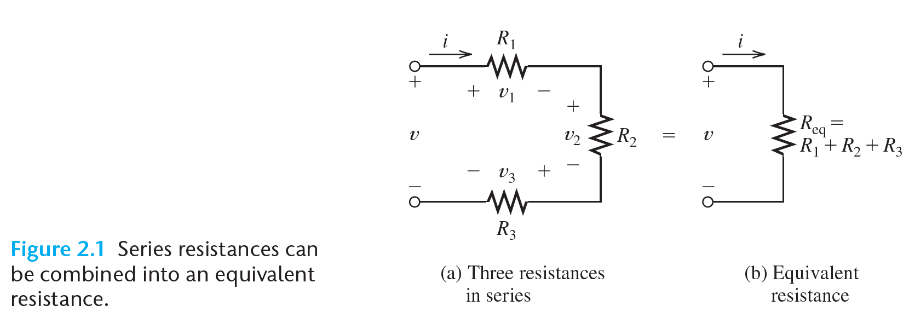
- Parallel Circuits: Resistors connected across the same two points share the same voltage. The total resistance in a parallel combination is given by:
$\frac{1}{R_{total}}=\frac{1}{R_{1}}+\frac{1}{R_{2}}+$…
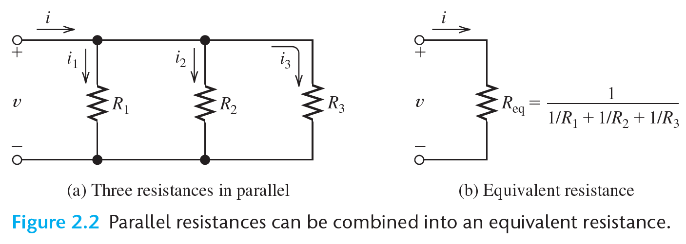
2. Kirchhoff’s Laws
- Kirchhoff’s Current Law (KCL): The sum of currents entering a node (or junction) is equal to the sum of currents leaving that node.
- Kirchhoff’s Voltage Law (KVL): The sum of voltages around any closed loop in a circuit is zero.
- These laws are essential for analyzing more complex resistive circuits involving multiple loops or junctions.
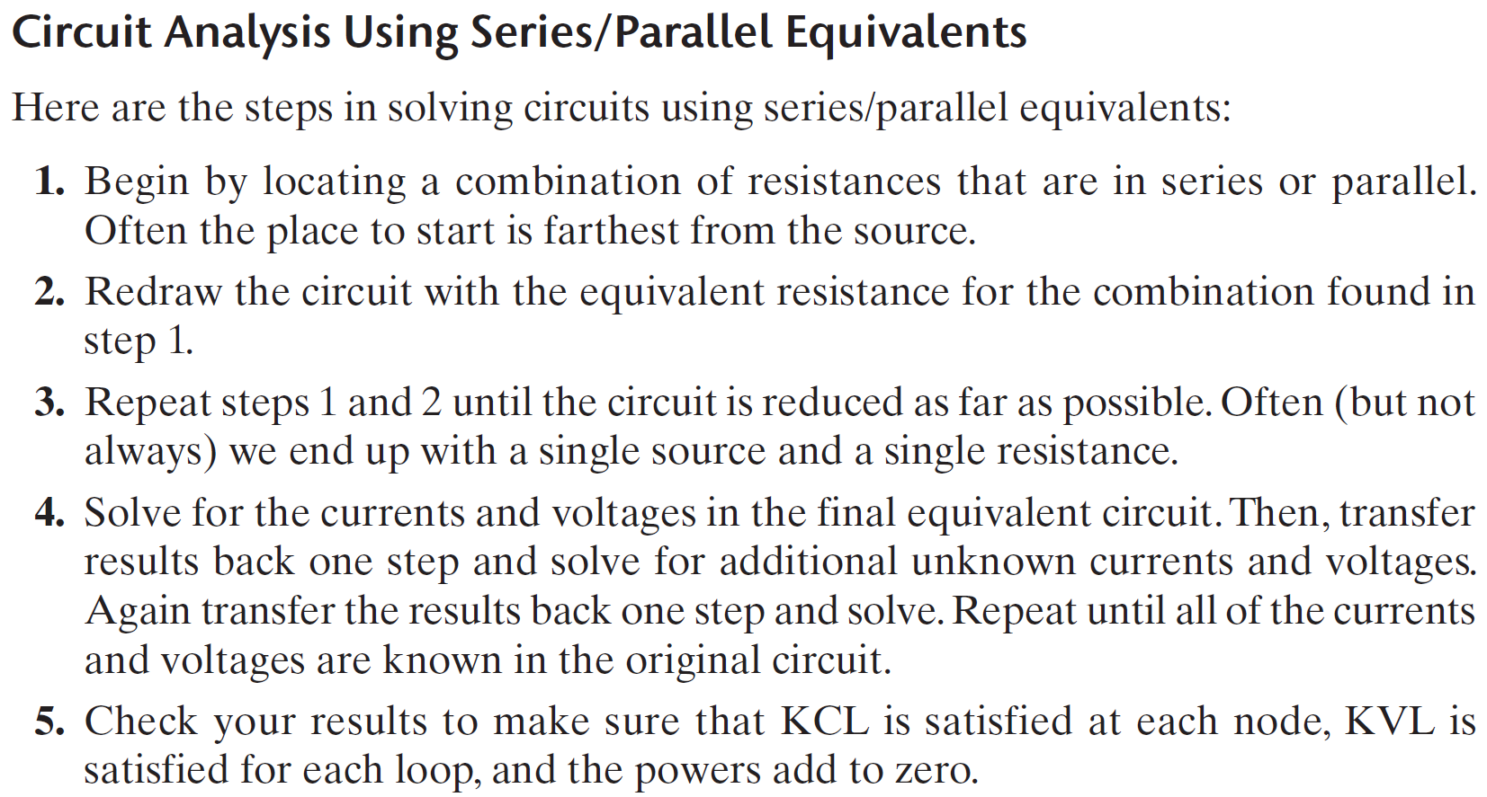
3. Voltage and Current Division
- Voltage-Division Principle: In a series resistive circuit, the voltage across a particular resistor is proportional to its resistance relative to the total series resistance. $V_{x}=V_{total}·\frac{R_{x}}{R_{total}}$
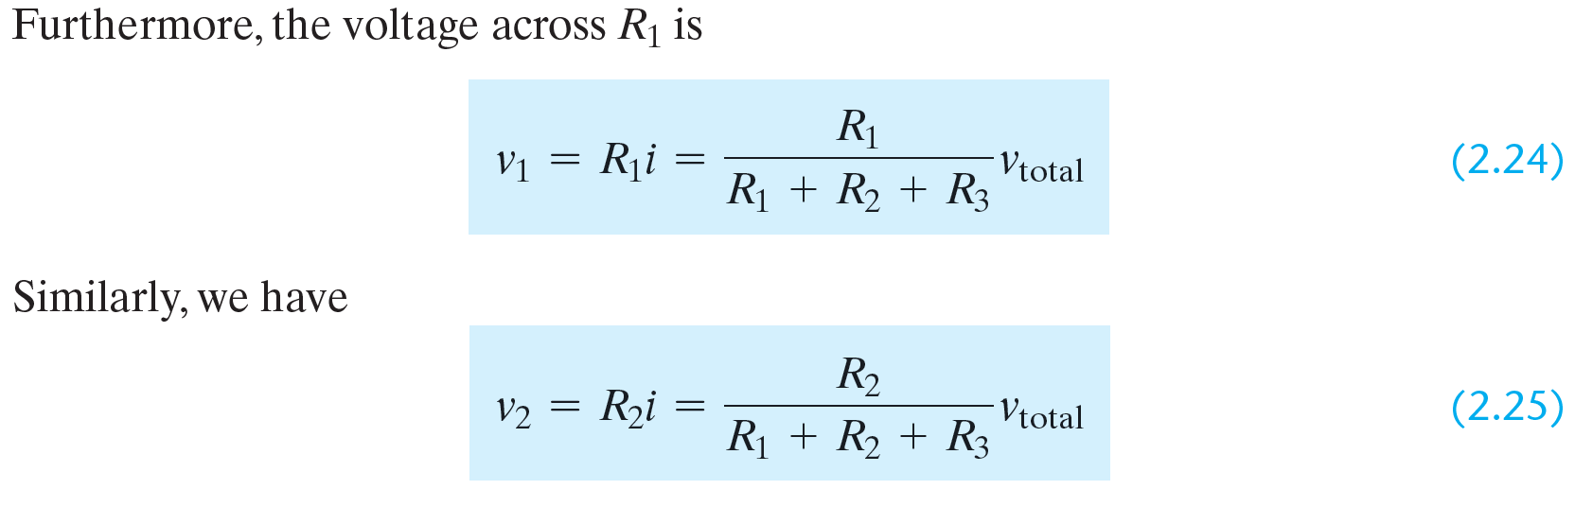
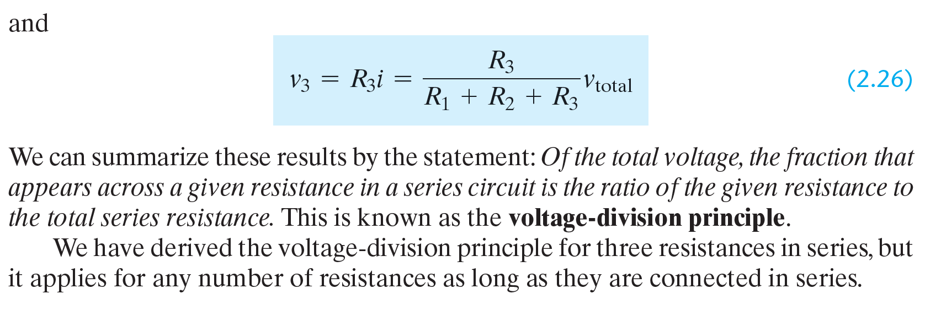
- Current Division Principle: In a parallel resistive circuit, the current through a particular branch is inversely proportional to its resistance. $I_{x}=I_{total}·\frac{R_{total}}{R_{x}}$
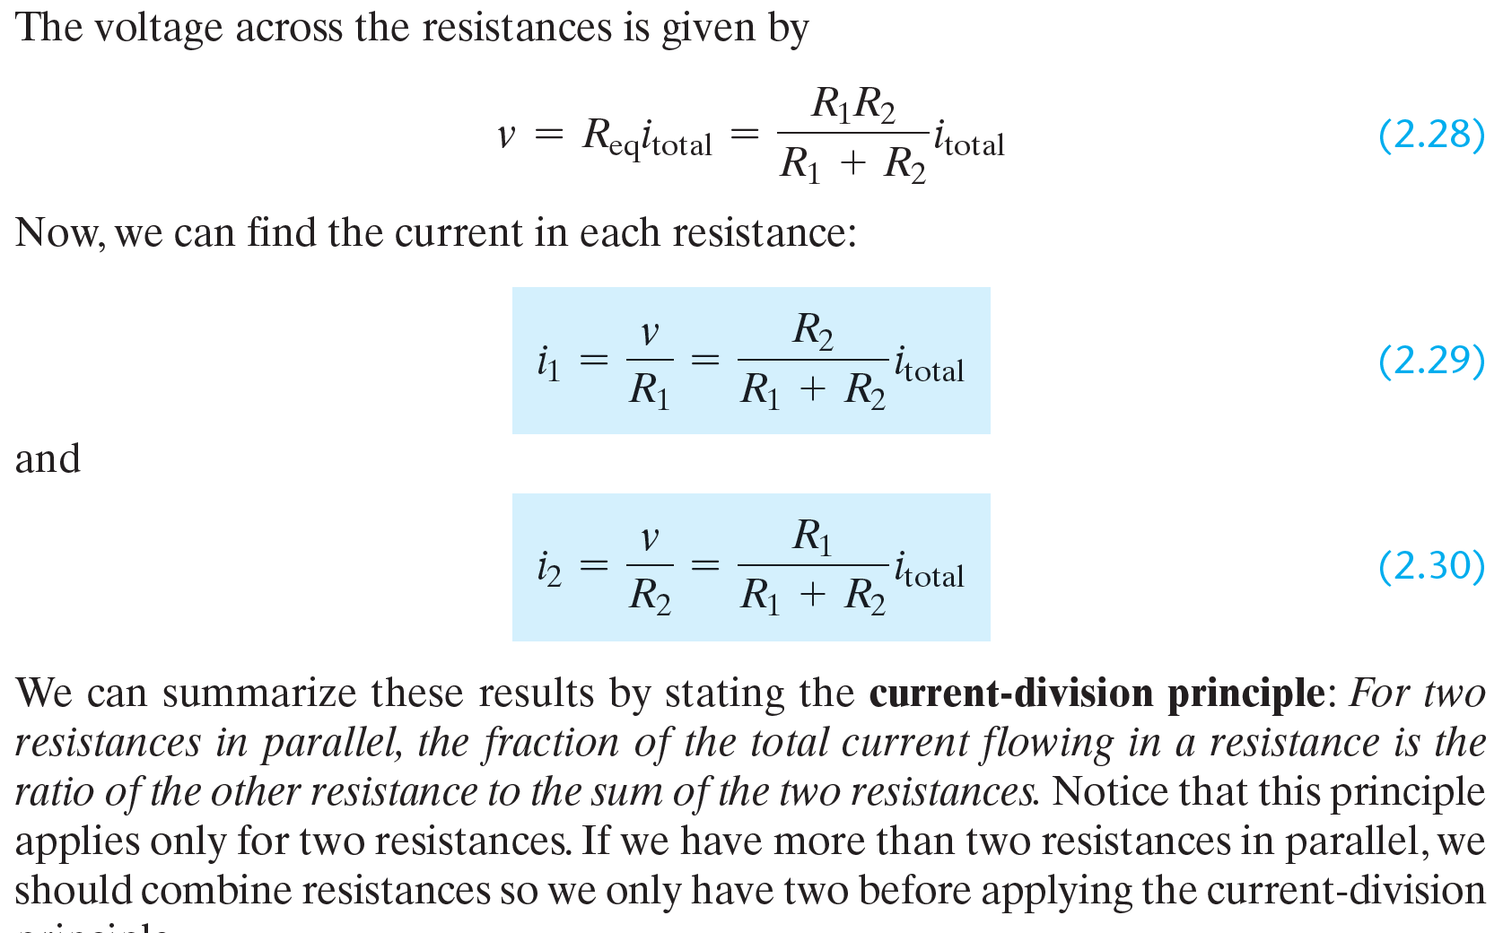
4. Nodal and Mesh Analysis
- Nodal Analysis: Uses KCL to establish node voltages as the primary unknowns. Each node leads to an equation involving currents entering and leaving.
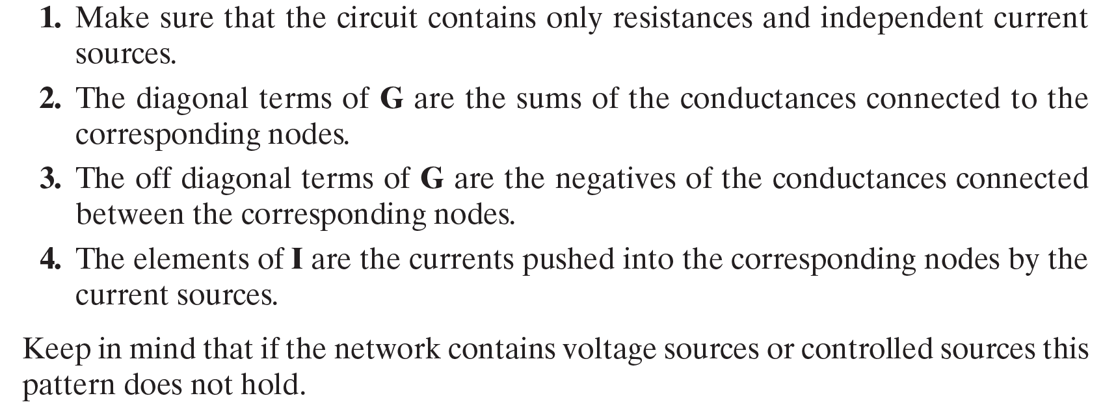
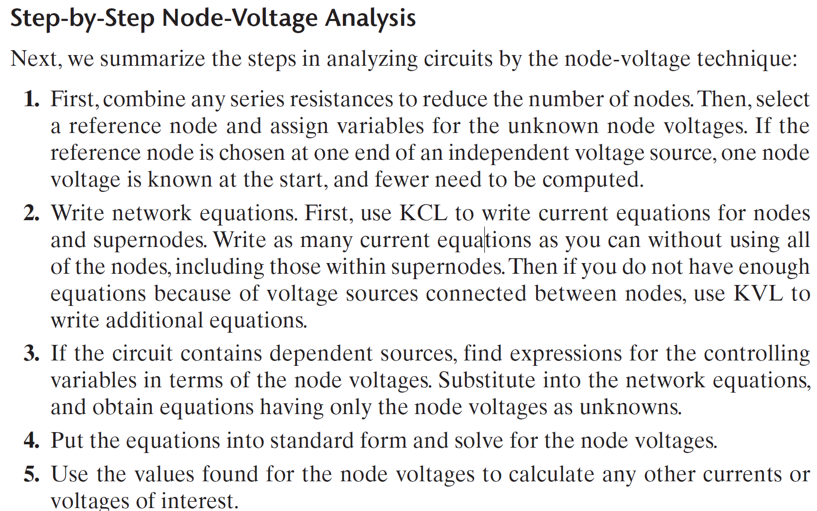

- Mesh Analysis: Uses KVL to establish loop currents as the primary unknowns. Each independent loop generates an equation for the voltage drops across resistors.
- Thevenin’s and Norton’s Theorems
- Thevenin’s Theorem: Any complex two-terminal resistive network can be replaced with a single equivalent voltage source ($V_{T}$) in series with a resistance ($R_{T}$)
- Norton’s Theorem: Any complex two-terminal resistive network can be replaced with a single current source ($I_{N}$) in parallel with a resistance ($R_{N}$​).
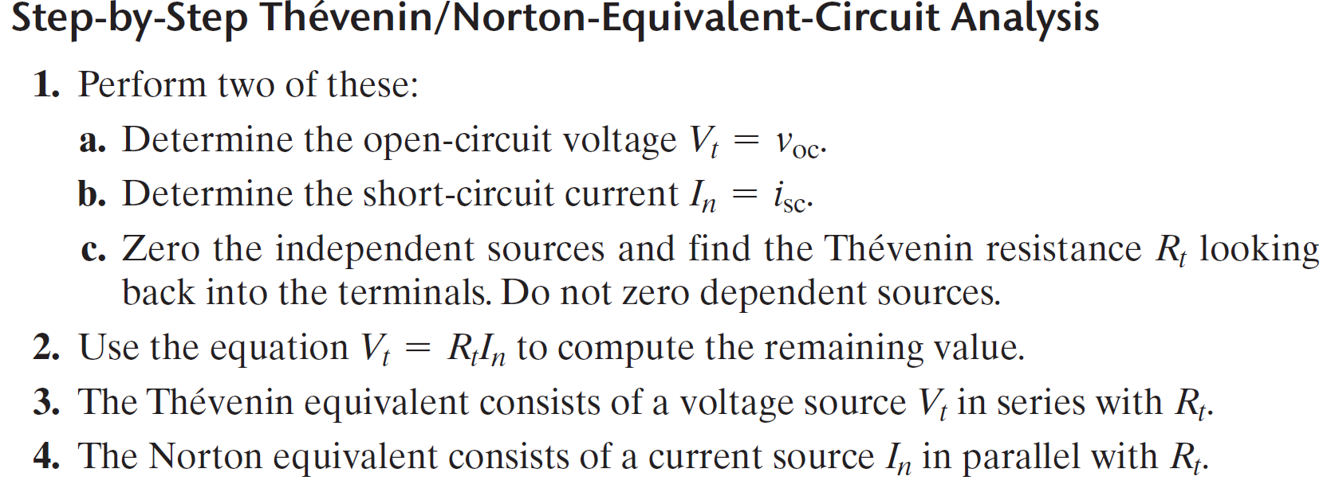
- These theorems simplify the analysis of circuits, especially when calculating the effect of varying loads on a circuit.
- Maximum Power Transfer Theorem: States that to achieve maximum power transfer to a load, the load resistance must equal the Thevenin resistance of the circuit supplying the power.
7. Superposition Theorem
- This theorem states that in a linear resistive circuit with multiple independent sources, the total response (voltage or current) at any point is the algebraic sum of the responses caused by each source acting alone, with all other independent sources replaced by their internal resistances.
- Power dissipated by a resistor is given by: $P=VI=I^{2}R=\frac{V^{2}}{R}$
8. Wheatstone Bridge
- A circuit used to measure unknown resistances (for example resistances of strain gauges)

